x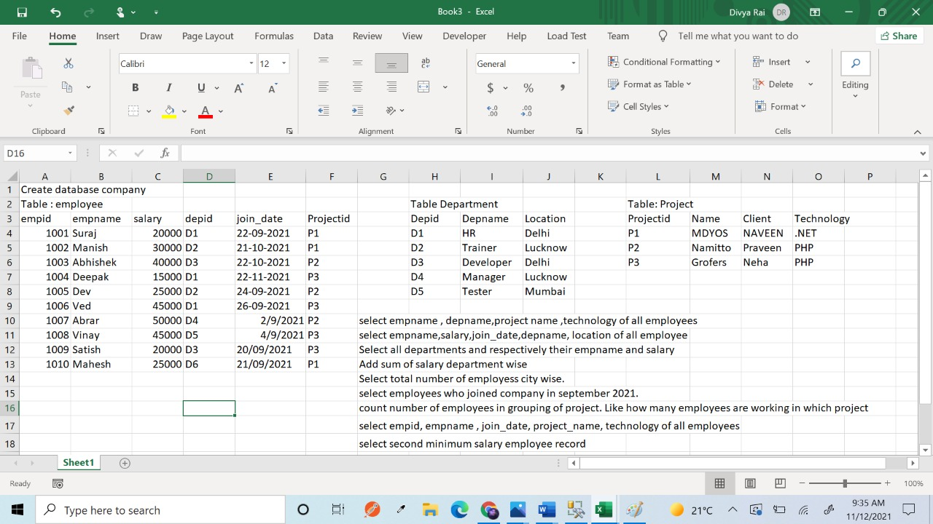

Q1. select e.empname,d.depname,p.name,p.technology from employee e inner join department d on e.depid=d.depid inner join project p on e.projectid=p.projectid

Q2. select e.empname,e.salary,e.join_date,d.depname,d.location from employee e inner join department d on e.depid=d.depid

Q3.

select d.depname,d.location ,e.empname,e.salary from employee e right join department d on e.depid=d.depid

Q4.

select d.depname,sum(e.salary) from employee e inner join department d on e.depid=d.depid group by d.depname

Q5.

select d.location,count(e.empname) from employee e inner join department d on e.depid=d.depid group by d.location

Q 6.

select *from employee where join_date like '2021/09%'

Q 7.

select p.technology, count(e.empname) from employee e inner join project p on e.projectid=p.projectid group by p.technology

Q 8.

select e.empid, e.empname,e.join_date,p.name,p.technology from employee e inner join project p on e.projectid=p.projectid

Q 9. select top 1 salary from employee where salary<>(select min(salary) from employee) order by salary asc